**<Online Mega Store>**

**Design Document**

**Version 1.0**



**Group Id: <S25PROJECT2F3EF>**

**Supervisor Name: <Muhammad Luqman>**

**Revision History**

|  |  |  |  |
| --- | --- | --- | --- |
| **Date (dd/mm/yyyy)** | **Version** | **Description** | **Author** |
| 7/12/2025 | 1.0 | This design document provides detailed descriptions and diagrams, including ERD, sequence diagrams, architecture design, class diagrams, database design, interface design, and test cases, to serve as a comprehensive blueprint for developing the online mega store web application. | BC210424933 |
|  |  |  |  |
|  |  |  |  |
|  |  |  |  |

**Table of Contents**

Introduction of Design Document:- 2

Entity Relationship Diagram (ERD) 8

Sequence Diagrams:- 9

Architecture Design Diagram:- 27

Class Diagram:- 28

Database Design 29

Interface Diagrams:- 30

1. Web Application Home Page UI:- 30

2. Registration Page UI:- 31

3. Login Page UI:- 32

4. User Panel UI:- 33

Test Cases:- 33

Test Case: Create Account 33

Test Case: Login 34

Test Case: Manage Orders 34

Test Case: Manage Products 34

Test Case: Manage Drop Shipping 35

Test Case: Integrate Payment Gateway 35

Test Case: Manage Customers 35

Test Case: Manage Discount and Coupon 36

Test Case: Set Profit Margin 36

Test Case: Generate Reports 36

Test Case: Product Listing 37

Test Case: Order Fulfill 37

Test Case: Manage Inventory 37

Test Case: Search Products 38

Test Case: Add to Cart 38

Test Case: View Product Details 38

Test Case: Checkout 38

Test Case: Track Order Status 39

Test Case: Receive Order Confirmation 39

Test Case: Submit Review 39

TASK#1

# Introduction of Design Document:-

This design document outlines the detailed design and architecture of the Mega Store web application. It includes essential diagrams and descriptions that provide a comprehensive understanding of the system's structure and behavior. The primary purpose of this document is to serve as a blueprint for the development team, ensuring that all aspects of the system are well-documented and clearly defined.

1. **Entity Relationship Diagram (ERD)**

* **Entities**: Represent objects or concepts, such as products, orders and reports that have data stored about them.
* **Relationships:** Illustrate how entities are connected
* **Attributes:**  Characteristics or properties of entities, such as User_id for Users or

This diagram provides a visual representation of the data model, illustrating the relationships between different entities within the system. This diagram is crucial for understanding how data is structured and interconnected.

1. **Sequence Diagrams:**

* **Objects:** Instances of classes that interact in the system.
* **Messages:** Communications between objects, shown as arrows.
* **Lifelines:** Represent the existence of an object over time.
* **Activation:** Represented by a thin rectangle or a tall, thin box, this shows when a participant is actively performing an action or operation.
* **Deactivation:** Represented by a small circle or a short, thin rectangle, this shows when a participant's action or operation is complete.
* **Conditions:** Represented by a diamond or a rectangle with a decision icon, these show the conditions or logic that govern the interactions.
* **Alternative paths:** Represented by a diamond or a rectangle with multiple outgoing arrows, these show alternative scenarios or branches.

Sequence diagrams are provided for each use case, detailing the interactions between objects over time. These diagrams help in visualizing the flow of tasks within the system and are essential for understanding the dynamic behavior of the system.

1. **Architecture Design Diagram:**

* **Layers:** Different levels of the system, such as presentation, business logic, and data access layers.
* **Components:** Functional units within each layer, like User Interface, and Database.
* **Interactions:** How layers and components communicate with each other.

The architecture design diagram presents a tiered architecture of the system, highlighting the different layers and their interactions. This section is important for understanding the overall structure and deployment of the system.

1. **Class Diagram:**

* **Classes:** Blueprints for objects, defining attributes and methods, like User, Admin.
* **Relationships:** Connections between classes, such as inheritance (Admin inherits from User), association, aggregation, and composition.
* **Attributes and Methods:** Characteristics and behaviors defined within each class. The class diagram provides a static view of the system, showing the system classes, their attributes, methods, and relationships. This diagram is fundamental for object-oriented design and development.
* **Inheritance:** Represented by an arrow pointing from a subclass to a super class, this shows the inheritance relationship between classes.
* **Composition:** Represented by a filled diamond at the end of a line connecting classes, this shows the whole-part relationship between classes.
* **Association:** Represented by a line connecting classes, this shows the relationship between classes, such as a student enrolling in a course.
* **Multiplicity:** Represented by numbers or symbols at the ends of a line connecting classes, this shows the cardinality of the relationship, such as one-to-one or many-to-many.
* **Dependencies:** Represented by a dashed arrow pointing from a dependent class to an independent class, this shows the dependency relationship between classes.
* **Interfaces:** Represented by a circle or a rectangle with a name, these define a contract or a set of operations that a class must implement.

1. %3CmxGraphModel%3E%3Croot%3E%3CmxCell%20id%3D%220%22%2F%3E%3CmxCell%20id%3D%221%22%20parent%3D%220%22%2F%3E%3CUserObject%20label%3D%22%22%20tags%3D%22Background%22%20id%3D%222%22%3E%3CmxCell%20style%3D%22vsdxID%3D1%3BfillColor%3Dnone%3BgradientColor%3Dnone%3BstrokeColor%3Dnone%3Bpoints%3D%5B%5B1%2C0.5%2C0%5D%2C%5B0.5%2C0.5%2C0%5D%2C%5B0.5%2C0%2C0%5D%5D%3BlabelBackgroundColor%3Dnone%3Brounded%3D0%3Bhtml%3D1%3BwhiteSpace%3Dwrap%3B%22%20vertex%3D%221%22%20parent%3D%221%22%3E%3CmxGeometry%20x%3D%22838%22%20y%3D%2234%22%20width%3D%22254%22%20height%3D%22401%22%20as%3D%22geometry%22%2F%3E%3C%2FmxCell%3E%3C%2FUserObject%3E%3CmxCell%20id%3D%223%22%20style%3D%22vsdxID%3D2%3BfillColor%3D%23ffffff%3BgradientColor%3Dnone%3Bshape%3Dstencil(rZBLDoAgDERP0z3SI%2Fi5B4kojQgE8Xd7IY3RuHY303lt0gGsF6OCBimWFP2kd%2BqTAWxASnJGR0pZAbaA9eCjHqNfXc8%2BqEIWNfutXDh4T5QNKU52lWDfMWrJvdA7%2FB%2F%2BC83i%2BXMga7mmd%2F7tJY%2B4U2wv)%3BstrokeColor%3D%23ffffff%3Bpoints%3D%5B%5B0%2C0.5%2C0%5D%2C%5B1%2C0.5%2C0%5D%2C%5B0.5%2C1%2C0%5D%2C%5B0.5%2C0%2C0%5D%5D%3BlabelBackgroundColor%3Dnone%3Brounded%3D0%3Bhtml%3D1%3BwhiteSpace%3Dwrap%3B%22%20vertex%3D%221%22%20parent%3D%222%22%3E%3CmxGeometry%20width%3D%22254%22%20height%3D%221%22%20as%3D%22geometry%22%2F%3E%3C%2FmxCell%3E%3CmxCell%20id%3D%224%22%20style%3D%22vsdxID%3D3%3BfillColor%3D%23d8d8d8%3BgradientColor%3Dnone%3Bshape%3Dstencil(nZBLDoAgDERP0z3SIyjew0SURgSD%2BLu9kMZoXLhwN9O%2BtukAlrNpJg1SzDH4QW%2FURgNYgZTkjA4UkwJUgGXng%2B6DX1zLfmoymdXo17xh5zmRJ6Q42BWCfc2oJfdAr%2BYv%2BAP9Cb7OJ3H%2F2JG1HNGz%2F84klThPVCc%3D)%3BstrokeColor%3D%23ffffff%3Bpoints%3D%5B%5B0%2C0.5%2C0%5D%2C%5B1%2C0.5%2C0%5D%2C%5B0.5%2C1%2C0%5D%2C%5B0.5%2C0%2C0%5D%5D%3BlabelBackgroundColor%3Dnone%3Brounded%3D0%3Bhtml%3D1%3BwhiteSpace%3Dwrap%3B%22%20vertex%3D%221%22%20parent%3D%222%22%3E%3CmxGeometry%20width%3D%22254%22%20height%3D%22401%22%20as%3D%22geometry%22%2F%3E%3C%2FmxCell%3E%3CmxCell%20id%3D%225%22%20value%3D%22%22%20style%3D%22vsdxID%3D4%3BedgeStyle%3Dnone%3Bdashed%3D1%3BdashPattern%3D2.00%202.00%3BstartArrow%3Dnone%3BendArrow%3Dnone%3BstartSize%3D5%3BendSize%3D5%3BstrokeColor%3D%23115582%3BspacingTop%3D0%3BspacingBottom%3D0%3BspacingLeft%3D0%3BspacingRight%3D0%3BverticalAlign%3Dmiddle%3Bhtml%3D1%3BlabelBackgroundC

%22600%22%20as%3D%22sourcePoint%22%2F%3E%3CmxPoint%20x%3D%22740%22%20y%3D%22550%22%20as%3D%22targetPoint%22%2F%3E%3C%2FmxGeometry%3E%3C%2FmxCell%3E%3CmxCell%20id%3D%22176%22%20value%3D%22%22%20style%3D%22endArrow%3Dnone%3Bhtml%3D1%3Brounded%3D0%3BexitX%3D0.063%3BexitY%3D0.994%3BexitDx%3D0%3BexitDy%3D0%3BexitPerimeter%3D0%3B%22%20edge%3D%221%22%20source%3D%2215%22%20parent%3D%221%22%3E%3CmxGeometry%20width%3D%2250%22%20height%3D%2250%22%20relative%3D%221%22%20as%3D%22geometry%22%3E%3CmxPoint%20x%3D%22650%22%20y%3D%22600%22%20as%3D%22sourcePoint%22%2F%3E%3CmxPoint%20x%3D%221537%22%20y%3D%22547%22%20as%3D%22targetPoint%22%2F%3E%3C%2FmxGeometry%3E%3C%2FmxCell%3E%3CmxCell%20id%3D%22177%22%20value%3D%22%22%20style%3D%22endArrow%3Dnone%3Bhtml%3D1%3Brounded%3D0%3B%22%20edge%3D%221%22%20parent%3D%221%22%3E%3CmxGeometry%20width%3D%2250%22%20height%3D%2250%22%20relative%3D%221%22%20as%3D%22geometry%22%3E%3CmxPoint%20x%3D%221491%22%20y%3D%22140%22%20as%3D%22sourcePoint%22%2F%3E%3CmxPoint%20x%3D%221716%22%20y%3D%22140%22%20as%3D%22targetPoint%22%2F%3E%3C%2FmxGeometry%3E%3C%2FmxCell%3E%3CmxCell%20id%3D%22178%22%20value%3D%22%22%20style%3D%22endArrow%3Dnone%3Bhtml%3D1%3Brounded%3D0%3BexitX%3D0.97%3BexitY%3D0.138%3BexitDx%3D0%3BexitDy%3D0%3BexitPerimeter%3D0%3B%22%20edge%3D%221%22%20source%3D%22143%22%20parent%3D%221%22%3E%3CmxGeometry%20width%3D%2250%22%20height%3D%2250%22%20relative%3D%221%22%20as%3D%22geometry%22%3E%3CmxPoint%20x%3D%221590%22%20y%3D%22640%22%20as%3D%22sourcePoint%22%2F%3E%3CmxPoint%20x%3D%221650%22%20y%3D%22640%22%20as%3D%22targetPoint%22%2F%3E%3C%2FmxGeometry%3E%3C%2FmxCell%3E%3CmxCell%20id%3D%22179%22%20value%3D%22%22%20style%3D%22endArrow%3Dnone%3Bhtml%3D1%3Brounded%3D0%3BentryX%3D0.597%3BentryY%3D1.023%3BentryDx%3D0%3BentryDy%3D0%3BentryPerimeter%3D0%3B%22%20edge%3D%221%22%20source%3D%2228%22%20target%3D%22133%22%20parent%3D%221%22%3E%3CmxGeometry%20width%3D%2250%22%20height%3D%2250%22%20relative%3D%221%22%20as%3D%22geometry%22%3E%3CmxPoint%20x%3D%22900%22%20y%3D%22480%22%20as%3D%22sourcePoint%22%2F%3E%3CmxPoint%20x%3D%22950%22%20y%3D%22430%22%20as%3D%22targetPoint%22%2F%3E%3C%2FmxGeometry%3E%3C%2FmxCell%3E%3CmxCell%20id%3D%22180%22%20value%3D%22%22%20style%3D%22endArrow%3Dnone%3Bhtm3D1%3Brounded%3D0%3BentryX%3D0.106%3BentryY%3D0.991%3BentryDx%3D0%3BentryDy%3D0%3BentryPerimeter%3D0%3B%22%20edge%3D%221%22%20target%3D%228%22%20parent%3D%221%22%3E%3CmxGeometry%20width%3D%2250%22%20height%3D%2250%22%20relative%3D%221%22%20as%3D%22geometry%22%3E%3CmxPoint%20x%3D%221030%22%20y%3D%221110%22%20as%3D%22sourcePoint%22%2F%3E%3CmxPoint%20x%3D%221080%22%20y%3D%221060%22%20as%3D%22targetPoint%22%2F%3E%3C%2FmxGeometry%3E%3C%2FmxCell%3E%3CmxCell%20id%3D%22181%22%20value%3D%22%22%20style%3D%22endArrow%3Dnone%3Bhtml%3D1%3Brounded%3D0%3BexitX%3D0.5%3BexitY%3D0%3BexitDx%3D0%3BexitDy%3D0%3BexitPerimeter%3D0%3B%22%20edge%3D%221%22%20source%3D%2247%22%20parent%3D%221%22%3E%3CmxGeometry%20width%3D%2250%22%20height%3D%2250%22%20relative%3D%221%22%20as%3D%22geometry%22%3E%3CmxPoint%20x%3D%221839%22%20y%3D%221134%22%20as%3D%22sourcePoint%22%2F%3E%3CmxPoint%20x%3D%221825.69%22%20y%3D%22839%22%20as%3D%22targetPoint%22%2F%3E%3C%2FmxGeometry%3E%3C%2FmxCell%3E%3CmxCell%20id%3D%22182%22%20value%3D%22%22%20style%3D%22endArrow%3Dnone%3Bhtml%3D1%3Brounded%3D0%3BentryX%3D0.991%3BentryY%3D0.865%3BentryDx%3D0%3BentryDy%3D0%3BentryPerimeter%3D0%3B%22%20edge%3D%221%22%20target%3D%2233%22%20parent%3D%221%22%3E%3CmxGeometry%20width%3D%2250%22%20height%3D%2250%22%20relative%3D%221%22%20as%3D%22geometry%22%3E%3CmxPoint%20x%3D%221715%22%20y%3D%221136%22%20as%3D%22sourcePoint%22%2F%3E%3CmxPoint%20x%3D%221720%22%20y%3D%221060%22%20as%3D%22targetPoint%22%2F%3E%3C%2FmxGeometry%3E%3C%2FmxCell%3E%3CmxCell%20id%3D%22183%22%20value%3D%22%22%20style%3D%22endArrow%3Dnone%3Bhtml%3D1%3Brounded%3D0%3BentryX%3D0.022%3BentryY%3D0.958%3BentryDx%3D0%3BentryDy%3D0%3BentryPerimeter%3D0%3BexitX%3D0.007%3BexitY%3D0.205%3BexitDx%3D0%3BexitDy%3D0%3BexitPerimeter%3D0%3B%22%20edge%3D%221%22%20source%3D%2242%22%20target%3D%22133%22%20parent%3D%221%22%3E%3CmxGeometry%20width%3D%2250%22%20height%3D%2250%22%20relative%3D%221%22%20as%3D%22geometry%22%3E%3CmxPoint%20x%3D%22883%22%20y%3D%221098%22%20as%3D%22sourcePoint%22%2F%3E%3CmxPoint%20x%3D%22720%22%20y%3D%22630%22%20as%3D%22targetPoint%22%2F%3E%3C%2FmxGeometry%3E%3C%2FmxCell%3E%3CmxCell%20id%3D%22184%22%20value%3D%22%22%20style%3D%22endArrow%3Dnone%3Bhtml%3D1%3Brounded%3D0%3BentryX%3D0.28%3BentryY%3D0.987%3BentryDx%3D0%3BentryDy%3D0%3BentryPerimeter%3D0%3B%22%20edge%3D%221%22%20source%3D%2233%22%20parent%3D%221%22%3E%3CmxGeometry%20width%3D%2250%22%20height%3D%2250%22%20relative%3D%221%22%20as%3D%22geometry%22%3E%3CmxPoint%20x%3D%221378%22%20y%3D%221100%22%20as%3D%22sourcePoint%22%2F%3E%3CmxPoint%20x%3D%221651%22%20y%3D%22749%22%20as%3D%22targetPoint%22%2F%3E%3C%2FmxGeometry%3E%3C%2FmxCell%3E%3CmxCell%20id%3D%22185%22%20value%3D%22%22%20style%3D%22endArrow%3Dnone%3Bhtml%3D1%3Brounded%3D0%3BexitX%3D0.97%3BexitY%3D-0.009%3BexitDx%3D0%3BexitDy%3D0%3BexitPerimeter%3D0%3BentryX%3D0.01%3BentryY%3D-0.008%3BentryDx%3D0%3BentryDy%3D0%3BentryPerimeter%3D0%3B%22%20edge%3D%221%22%20source%3D%2238%22%20target%3D%22153%22%20parent%3D%221%22%3E%3CmxGeometry%20width%3D%2250%22%20height%3D%2250%22%20relative%3D%221%22%20as%3D%22geometry%22%3E%3CmxPoint%20x%3D%22596%22%20y%3D%22968%22%20as%3D%22sourcePoint%22%2F%3E%3CmxPoint%20x%3D%221262%22%20y%3D%22850%22%20as%3D%22targetPoint%22%2F%3E%3C%2FmxGeometry%3E%3C%2FmxCell%3E%3CmxCell%20id%3D%22186%22%20value%3D%22%22%20style%3D%22endArrow%3Dnone%3Bhtml%3D1%3Brounded%3D0%3BentryX%3D0.014%3BentryY%3D0.819%3BentryDx%3D0%3BentryDy%3D0%3BentryPerimeter%3D0%3B%22%20edge%3D%221%22%20target%3D%22101%22%20parent%3D%221%22%3E%3CmxGeometry%20width%3D%2250%22%20height%3D%2250%22%20relative%3D%221%22%20as%3D%22geometry%22%3E%3CmxPoint%20x%3D%221134%22%20y%3D%22683%22%20as%3D%22sourcePoint%22%2F%3E%3CmxPoint%20x%3D%221262%22%20y%3D%22683%22%20as%3D%22targetPoint%22%2F%3E%3C%2FmxGeometry%3E%3C%2FmxCell%3E

1. **Database Design:**

* **Tables:** Structures that store data, corresponding to entities in the ERD.
* **Columns:** Fields within tables, representing attributes.
* **Relationships:** Connections between tables, implemented via foreign keys. The database design section includes diagrams that detail the schema of the database, ensuring that the data is organized efficiently and supports the application's requirements.

1. **Interface Design:**

* **Screenshots:** Visual representations of the user interface.
* **Layouts:** Arrangement of elements on the screen.
* **User Interactions:** How users interact with the interface.
* **Accessibility:** A description of the accessibility features and considerations, including WCAG guidelines and screen reader support.
* **Responsive Design:** A description of the responsive design approach, including breakpoints, layouts, and media queries.
* **Design Rationale:** A explanation of the design decisions, including the reasoning behind the design choices.

This section provides screenshots of the system's graphical user interface (GUI). It show cases the main interfaces, demonstrating the application's most important features and how users will interact with the system.

**8. Test Cases:**

* **Test Scenarios:** Specific situations to be tested.
* **Test Steps:** Detailed actions to perform the test.
* **Expected Results:** Anticipated outcomes of the test.

Test cases for each use case scenario are provided to ensure that the system's functionality is thoroughly tested. This section is vital for validating the system against its requirements and ensuring its reliability.

**Benefits and Purpose of the Design Phase:**

The design phase in a software development project is critical for several reasons:

* **Clarity and Communication:** It provides a clear and shared understanding of the system among all stakeholders, including developers, designers, and clients.
* **Blueprint for Development:** It serves as a detailed blueprint that guides the development process, ensuring that all components are developed in a coherent and consistent manner.
* **Risk Mitigation:** By defining the system architecture and design early potential issues can be identified and addressed before implementation begins, reducing risks and avoiding costly changes later.
* **Quality Assurance:** Detailed design documentation supports rigorous testing and validation, helping to ensure that the final product meets the specified requirements and standards.
* **Scalability and Maintenance:** A well-thought-out design facilitates future scalability and ease of maintenance, allowing the system to evolve with changing requirements.

This document is instrumental in ensuring the successful development and deployment of the Mega Store web application, providing a solid foundation for building a robust, efficient, and user-friendly application.

TASK#2

# Entity Relationship Diagram (ERD)

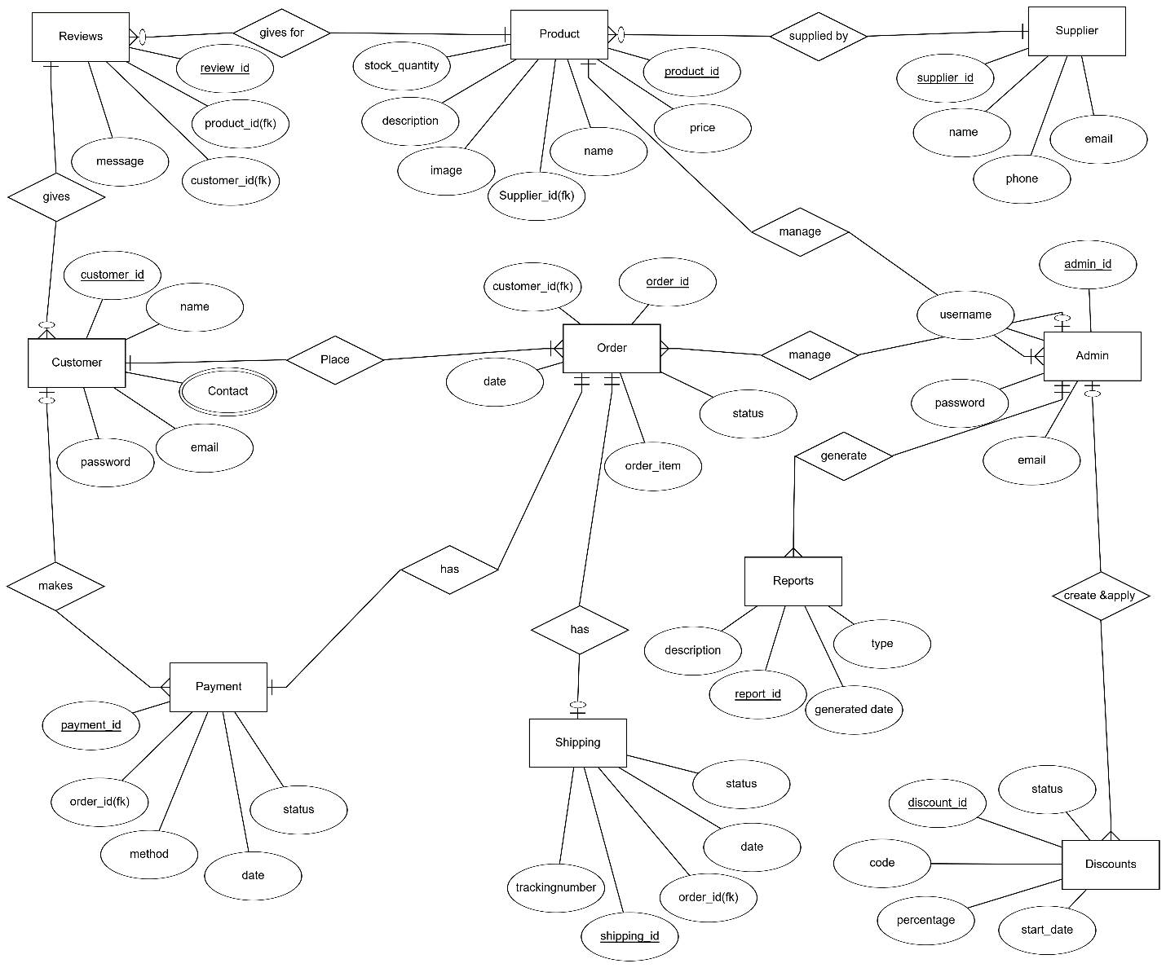

**Figure 1**

TASK#3

# Sequence Diagrams:-

1. **Create Account:-**

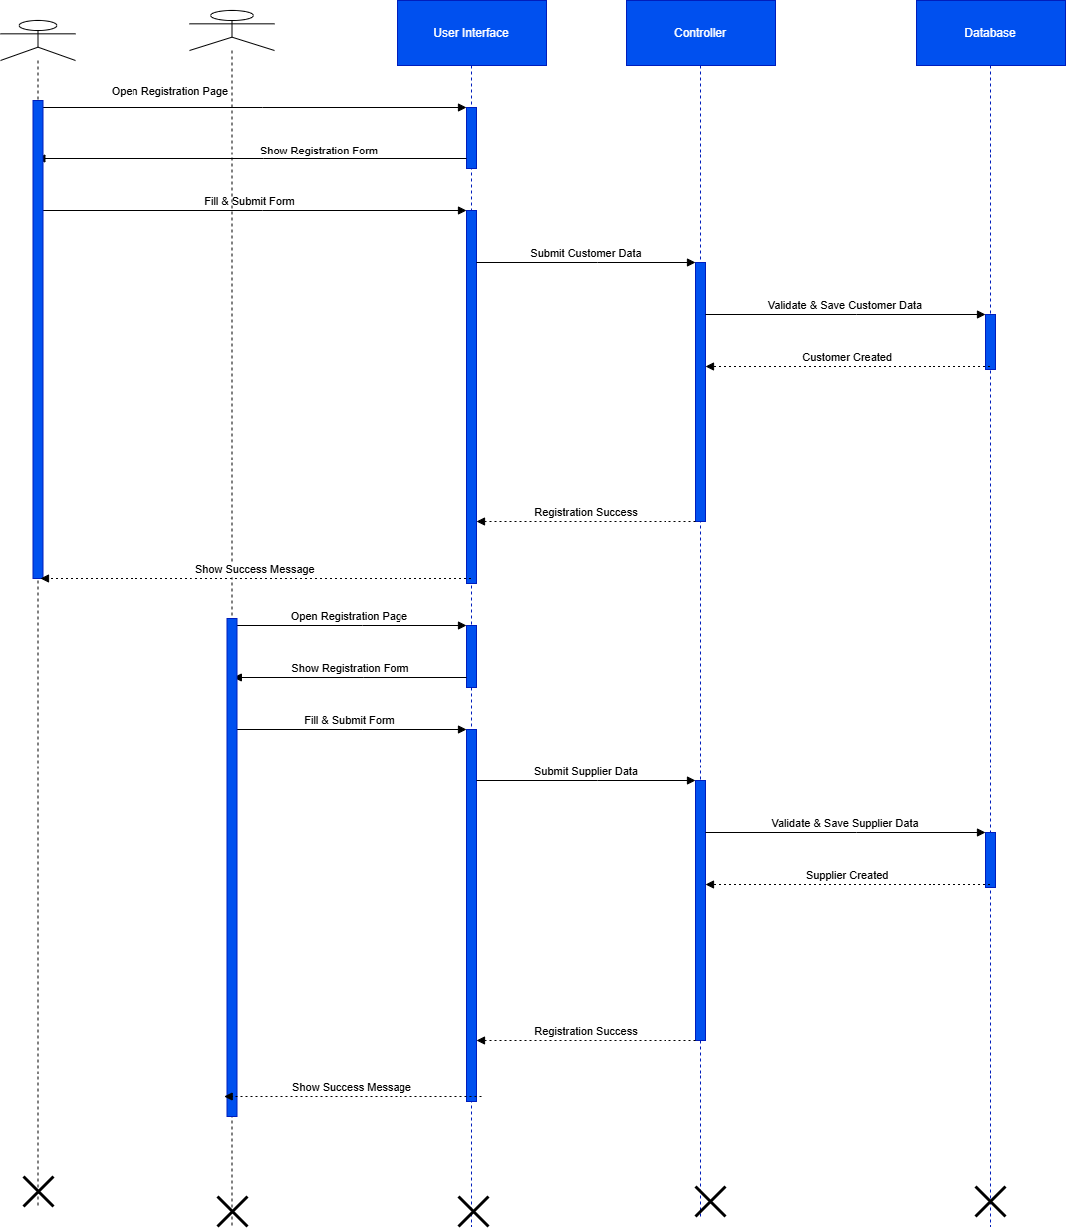

**Figure 2**

1. **Login:-**

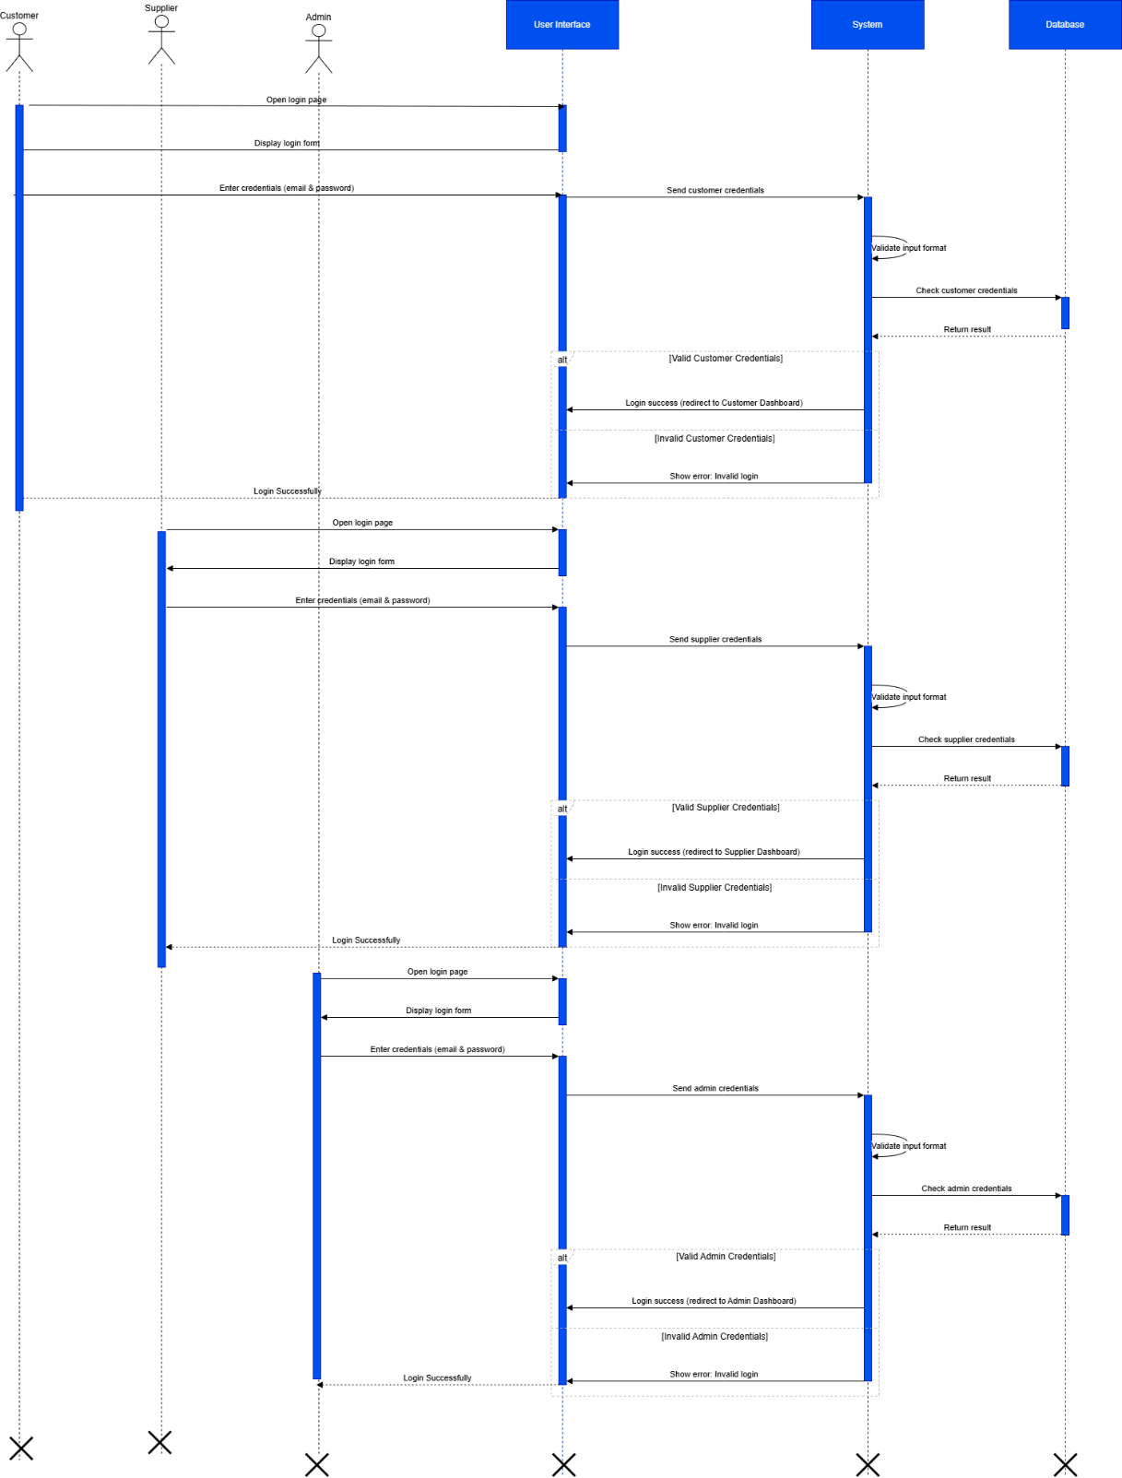

**Figure 3**

1. **search Product:-**

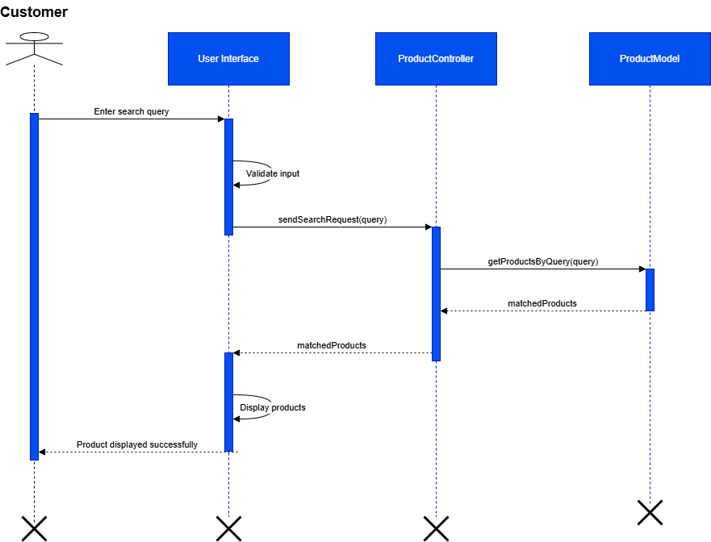

**Figure 4**

1. **View Products:**

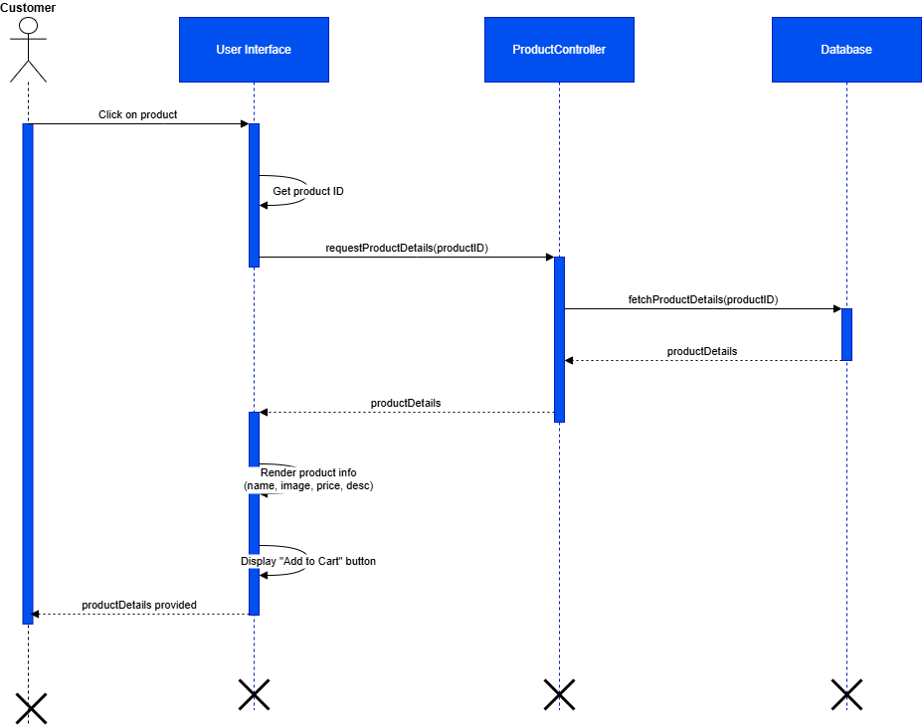

**Figure 5**

1. **Add To Cart:**

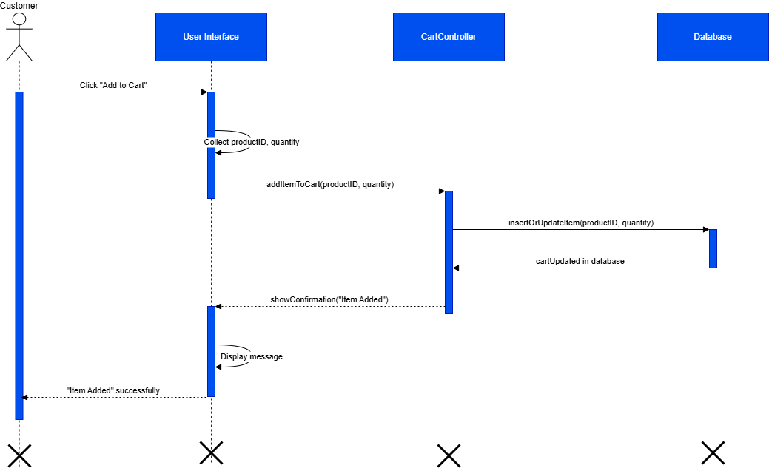

**Figure 6**

1. **Place Order:-**

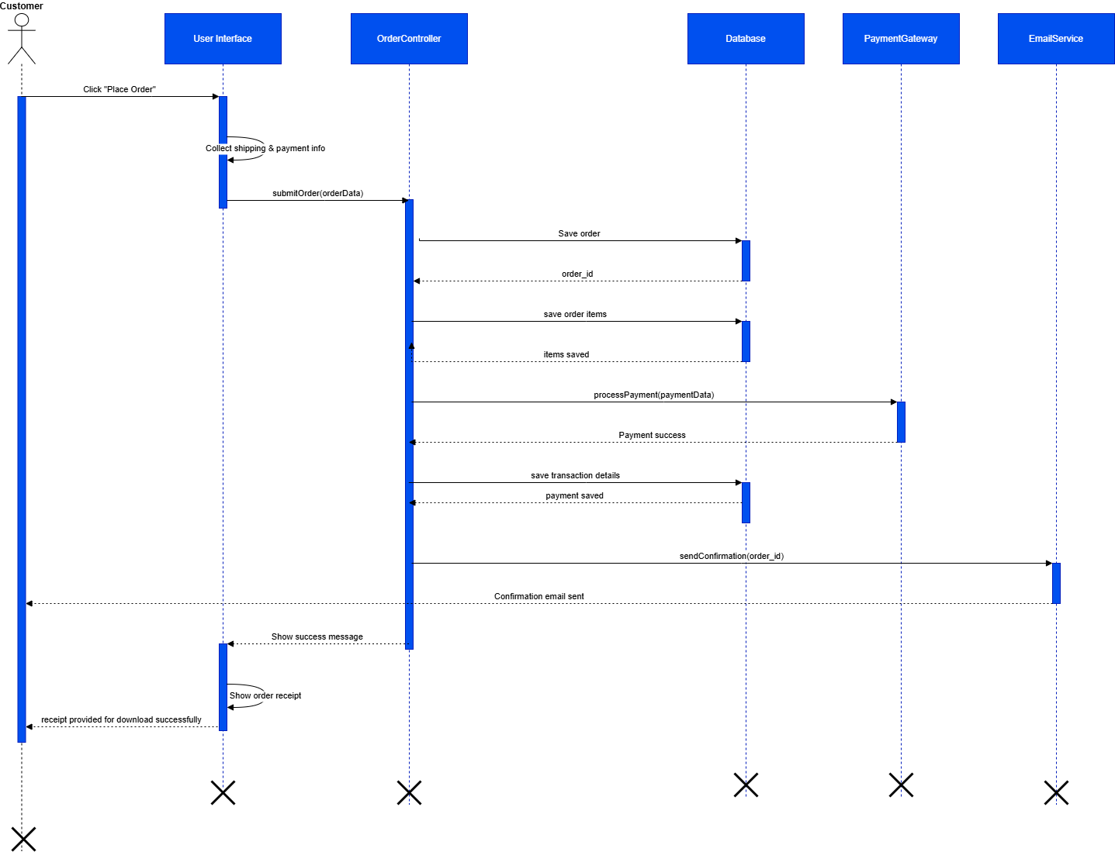

**Figure 7**

1. **Track Order:-**

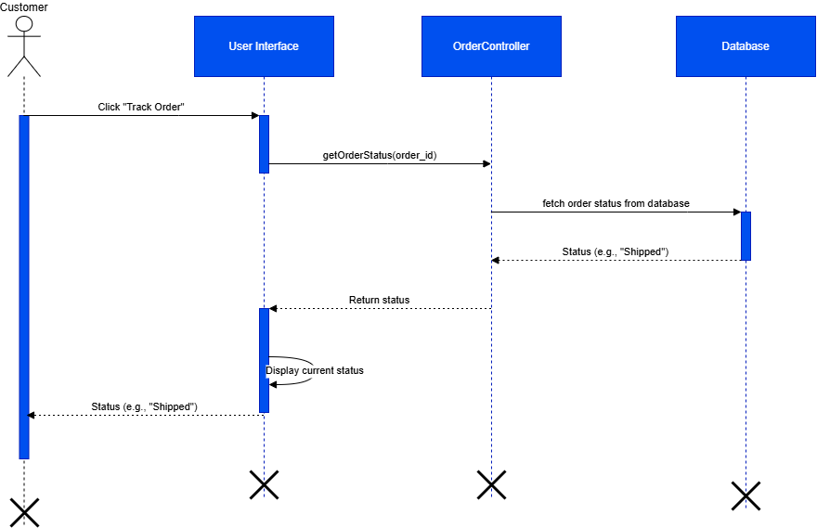

**Figure 8**

1. **List Products:-**

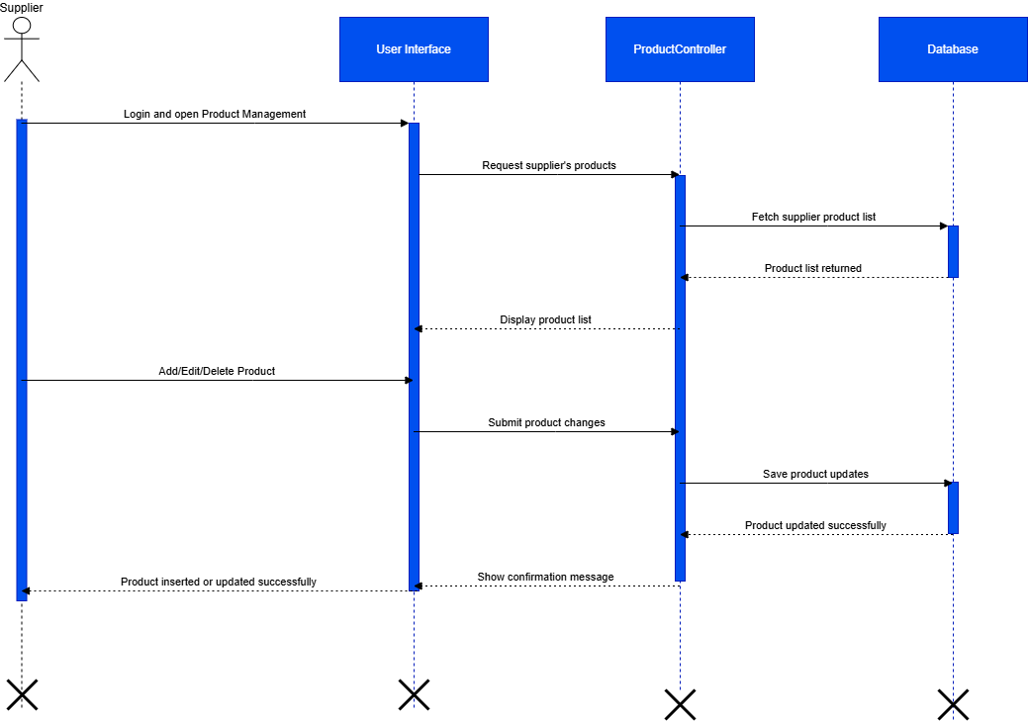

**Figure 9**

1. **Order Fulfillment:-**

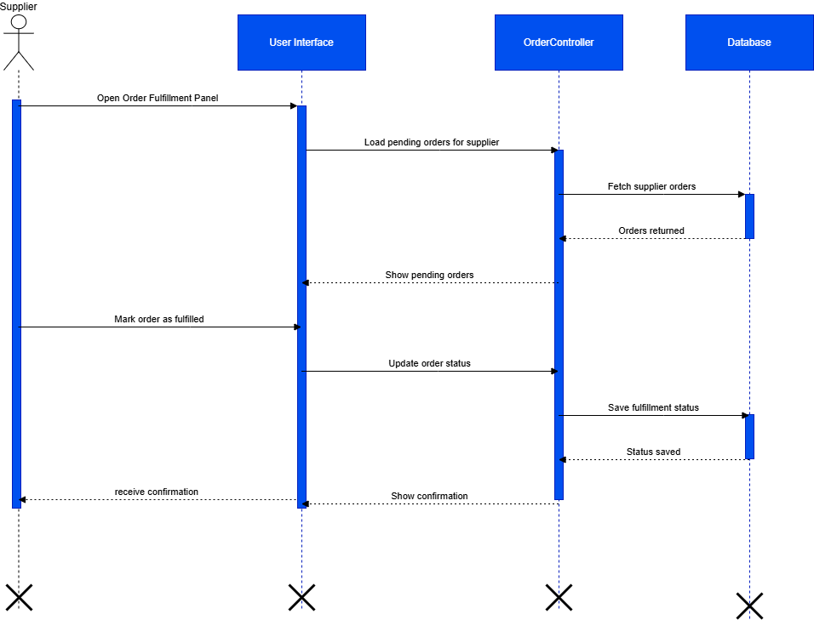

**Figure 10**

1. **Manage Inventory:-**

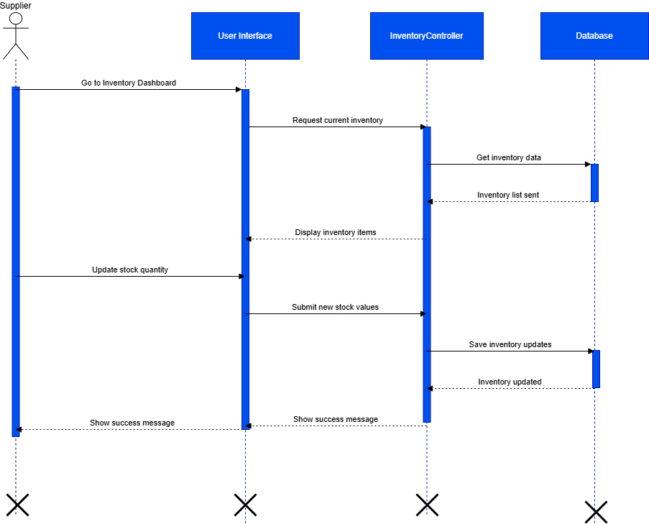

**Figure 11**

1. **Manage Customers:-**

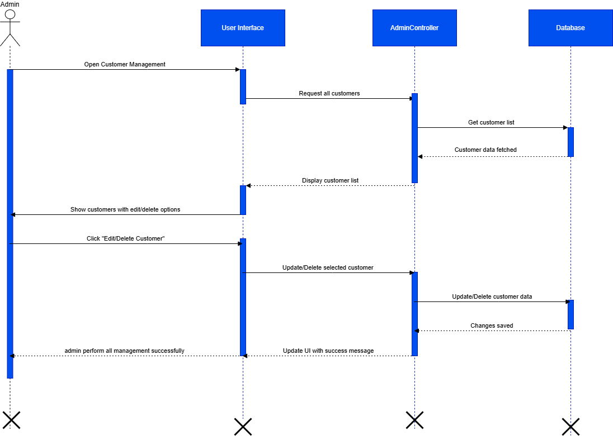

**Figure 12**

1. **Manage Products:-**

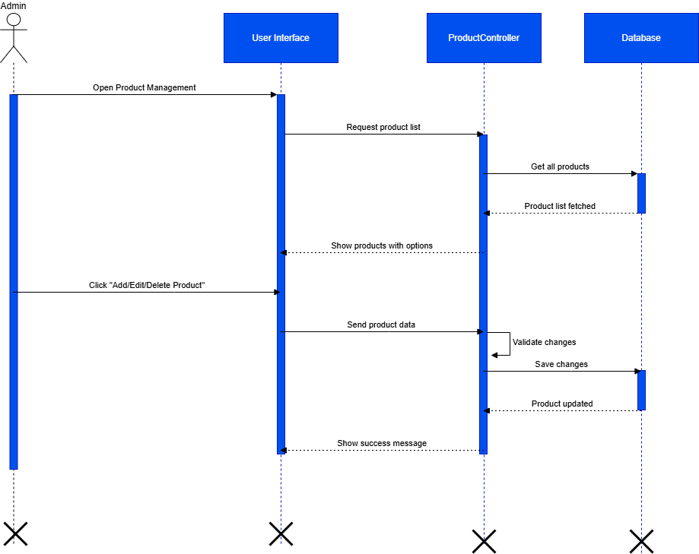

**Figure 13**

1. **Manage Orders:-**

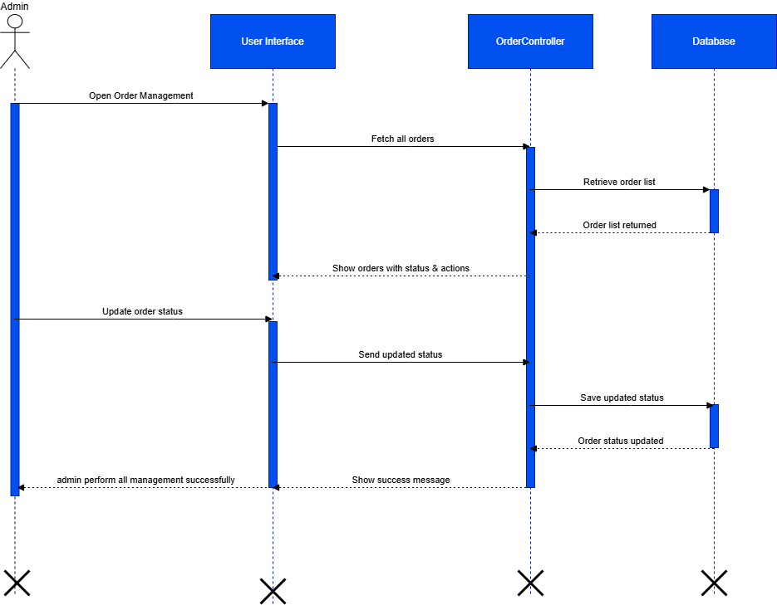

**Figure 14**

1. **Manage Drop Shipping:-**

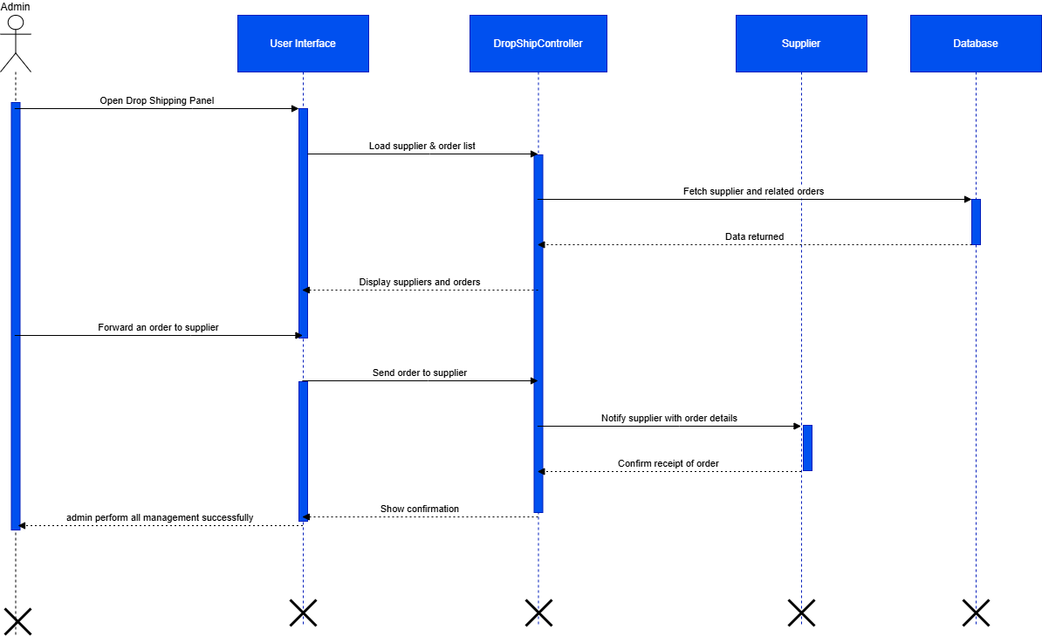

**Figure 15**

1. **Set Profit:-**

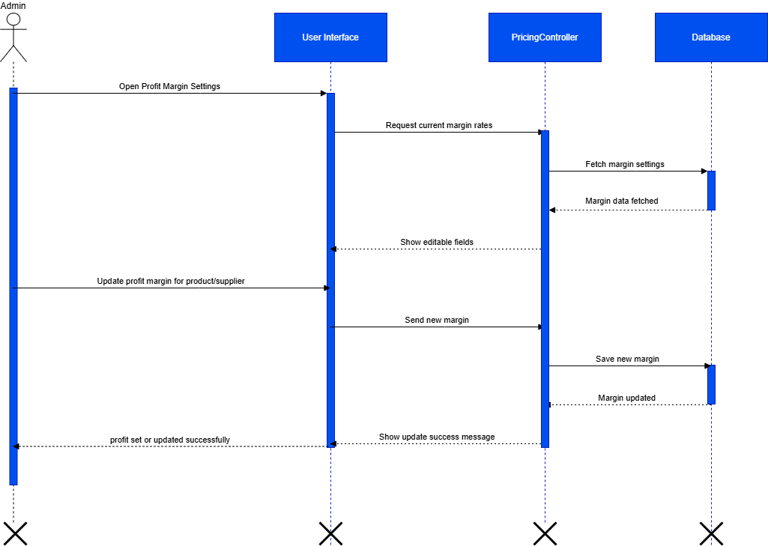

**Figure 16**

1. **Generate Reports:-**

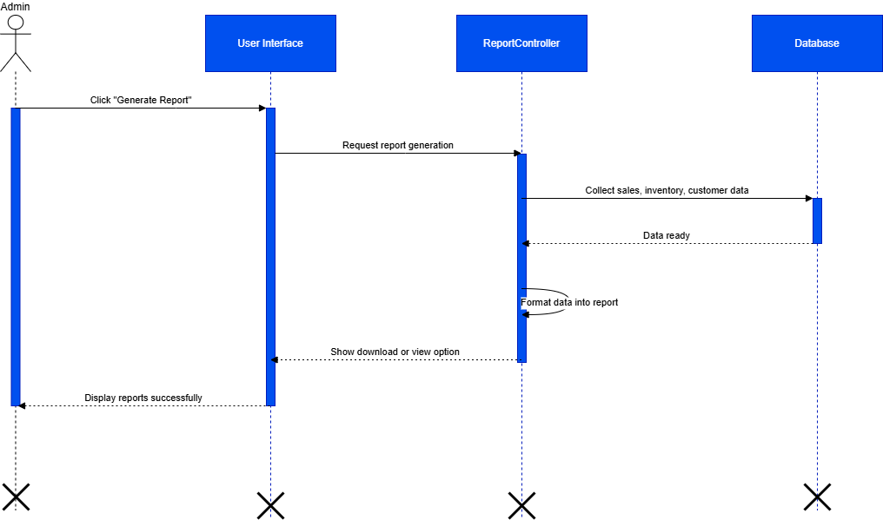

**Figure 17**

**Logout:-**

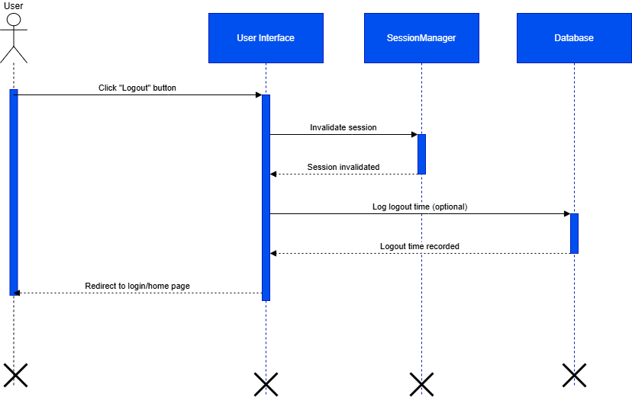

**Figure 18**

TASK#4

# Architecture Design Diagram:-

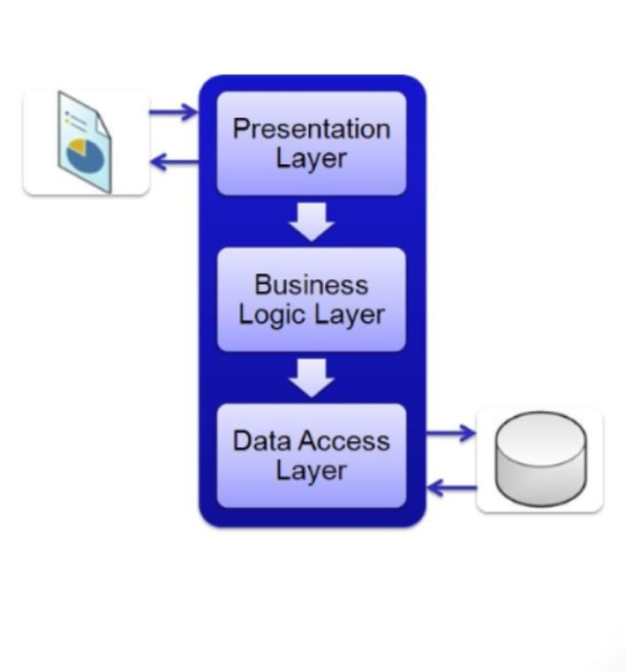

**Figure 19**

TASK#5

# Class Diagram:-

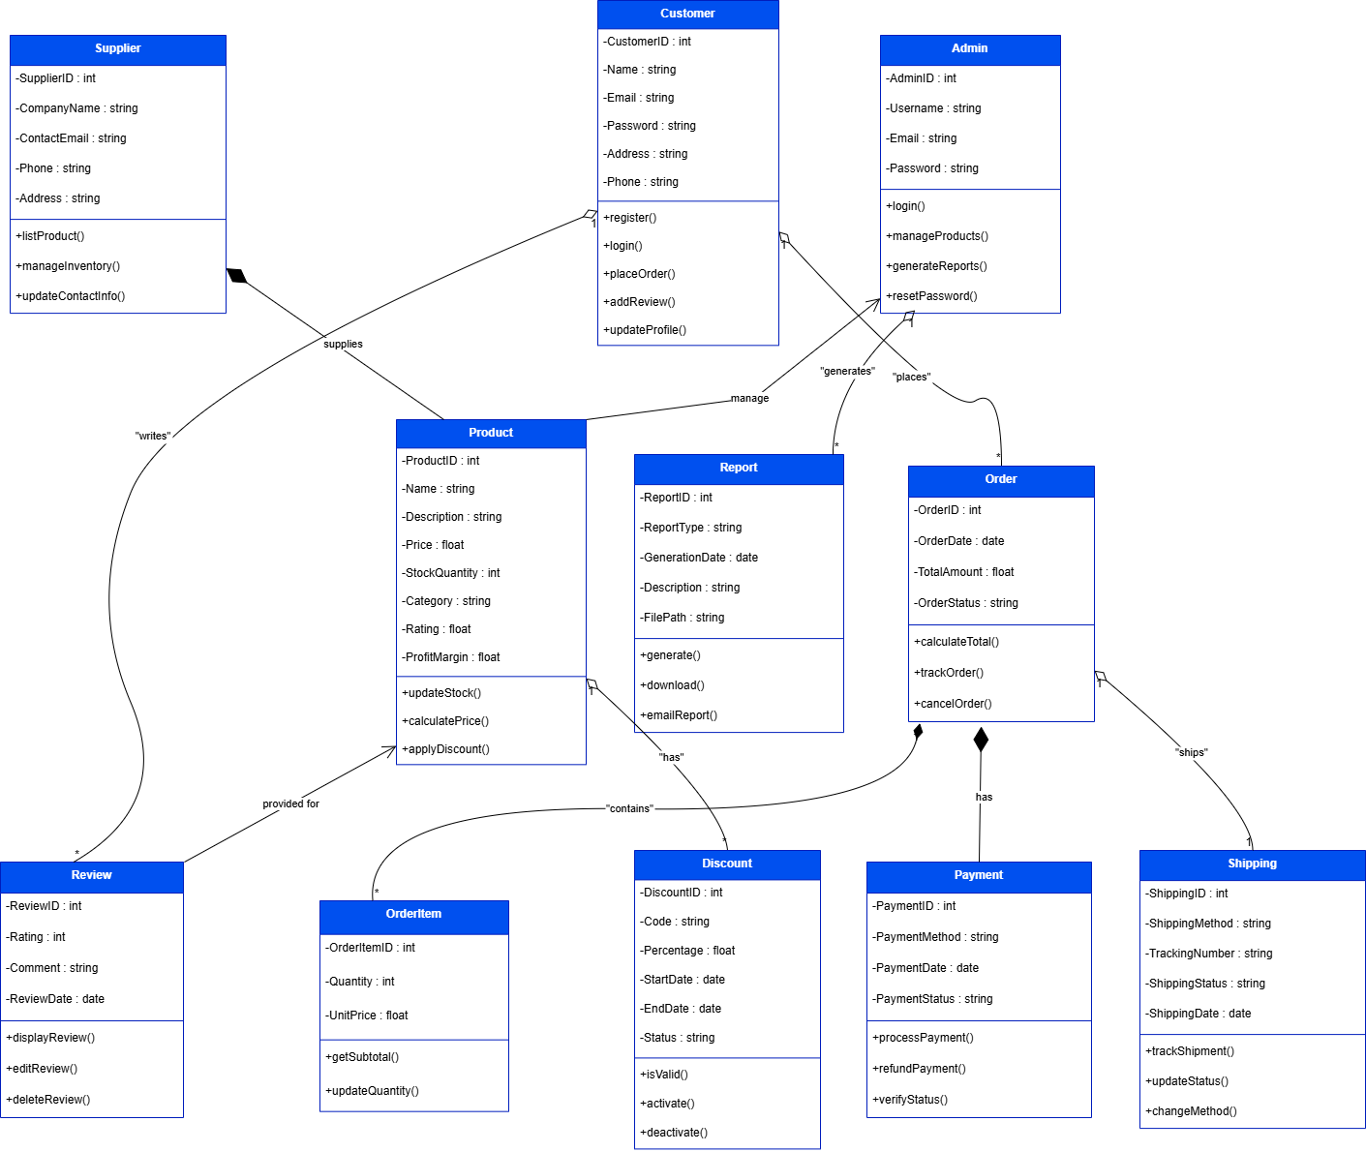

**Figure 20**

TASK#6

# Database Design

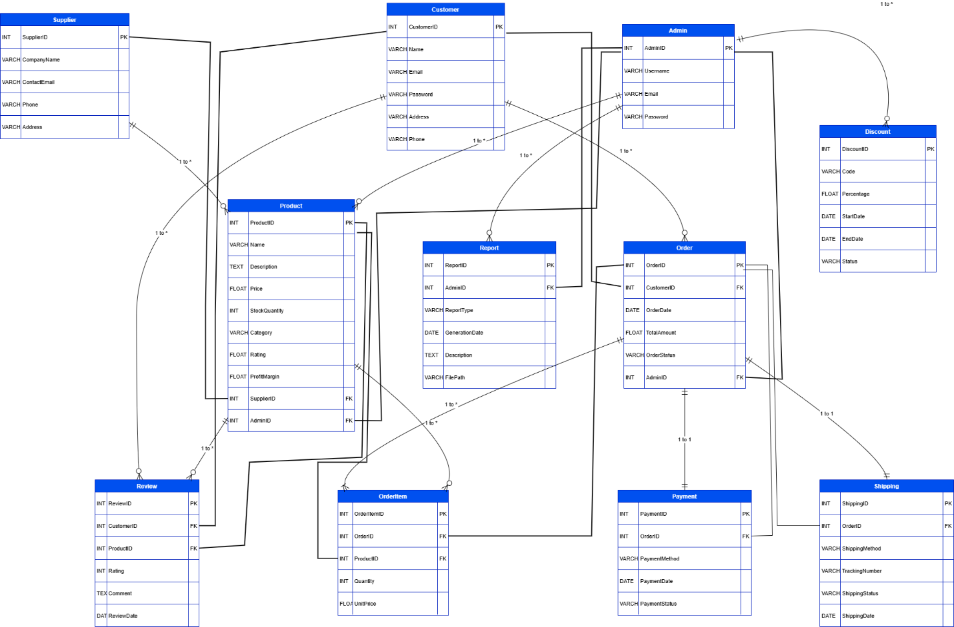

**Figure 21**

TASK#7

# Interface Diagrams:-

1. **Web Application Home Page UI:-**



**Interface 1**

1. **Registration Page UI:-**

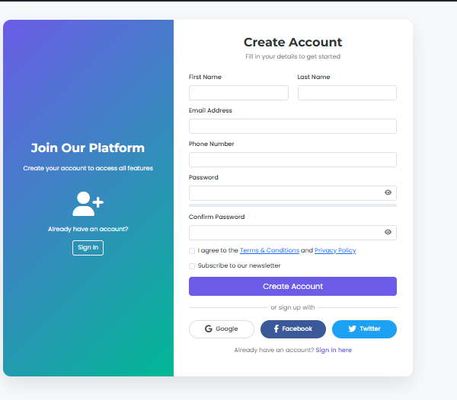

**Interface 2**

1. **Login Page UI:-**

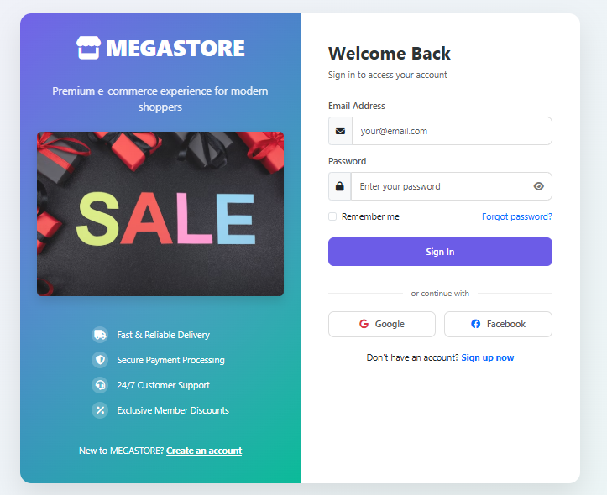

**Interface 3**

1. **User Panel UI:-**

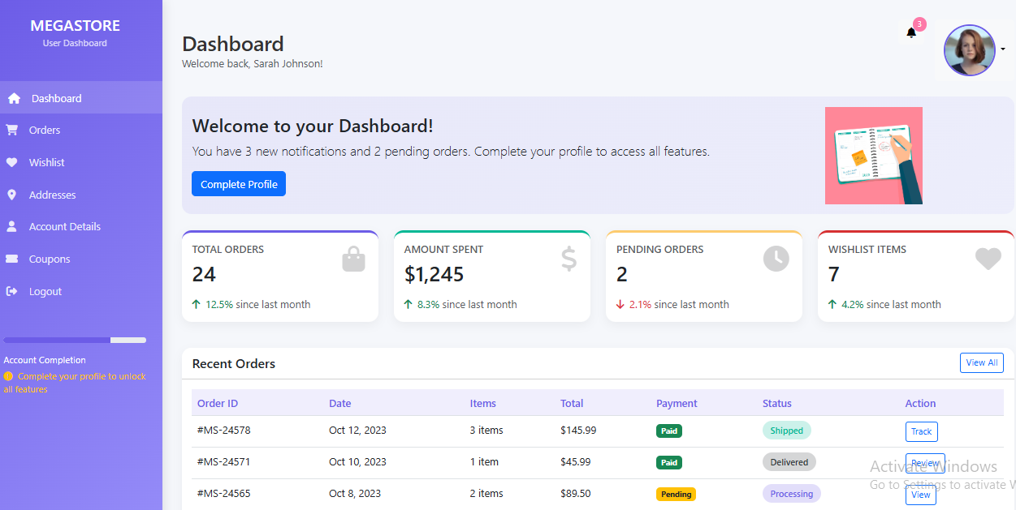

**Interface 4**

TASK#8 :

# Test Cases:-

## **Test Case: Create Account**

|  |  |
| --- | --- |
| Test Case ID | OMS_01 |
| Test Case Name | Create Account |
| Description | Test user registration |
| Test Steps | 1. Go to registration page 2. Enter info 3. Submit form |
| Test Data | Name, Email, Password, Address |
| Expected Results | Account created & confirmation sent |
| Test Result | Yes |
| Tested By | BC210424933 |

## **Test Case: Login**

|  |  |
| --- | --- |
| Test Case ID | OMS_02 |
| Test Case Name | Login |
| Description | Test user login with valid credentials |
| Test Steps | 1. Go to login page 2. Enter credentials 3. Submit |
| Test Data | Email, Password |
| Expected Results | User redirected to dashboard |
| Test Result | Yes |
| Tested By | BC210424933 |

## **Test Case: Manage Orders**

|  |  |
| --- | --- |
| Test Case ID | OMS_03 |
| Test Case Name | Manage Orders |
| Description | Test admin viewing and updating order status |
| Test Steps | 1. Login as Admin 2. Open Order Management 3. Update status |
| Test Data | Order ID, Status |
| Expected Results | Order status updated or order deleted. |
| Test Result | Yes |
| Tested By | BC210424933 |

## **Test Case: Manage Products**

|  |  |
| --- | --- |
| Test Case ID | OMS_04 |
| Test Case Name | Manage Products |
| Description | Test admin adding a new product |
| Test Steps | 1. Login as Admin 2. Open Product Managements 3. Add Product |
| Test Data | Name, Price, Description |
| Expected Results | Product saved and visible |
| Test Result | Yes |
| Tested By | BC210424933 |

## **Test Case: Manage Drop Shipping**

|  |  |
| --- | --- |
| Test Case ID | OMS_05 |
| Test Case Name | Manage Drop Shipping |
| Description | Test admin managing supplier orders |
| Test Steps | 1. Login 2. View supplier orders 3. Update status |
| Test Data | Supplier ID, Order ID |
| Expected Results | Status updated |
| Test Result | Yes |
| Tested By | BC210424933 |

## **Test Case: Integrate Payment Gateway**

|  |  |
| --- | --- |
| Test Case ID | OMG_06 |
| Test Case Name | Integrate Payment Gateway |
| Description | Test admin payment setup |
| Test Steps | 1. Login 2. Open Payment Settings 3. Enter API keys |
| Test Data | API Keys, Gateway Type |
| Expected Results | Gateway integrated |
| Test Result | Yes |
| Tested By | BC210424933 |

## **Test Case: Manage Customers**

|  |  |
| --- | --- |
| Test Case ID | OMS_07 |
| Test Case Name | Manage Customers |
| Description | Test admin viewing and updating customer |
| Test Steps | 1. Login 2. Open Customer Management  3. Edit Profile |
| Test Data | Customer ID, Info |
| Expected Results | Customer updated |
| Test Result | Yes |
| Tested By | BC210424933 |

## **Test Case: Manage Discount and Coupon**

|  |  |
| --- | --- |
| Test Case ID | OMS_08 |
| Test Case Name | Manage Discount and Coupon |
| Description | Test coupon creation |
| Test Steps | 1. Login 2. Open Promo 3. Add Coupon |
| Test Data | Code, % Discount, Expiry |
| Expected Results | Coupon created |
| Test Result | Yes |
| Tested By | BC210424933 |

## **Test Case: Set Profit Margin**

|  |  |
| --- | --- |
| Test Case ID | OMS_09 |
| Test Case Name | Set Profit Margin |
| Description | Test profit margin setting |
| Test Steps | 1. Login 2. Select Product 3. Enter Margin |
| Test Data | Product ID, % Margin |
| Expected Results | Price updated |
| Test Result | Yes |
| Tested By | BC210424933 |

## **Test Case: Generate Reports**

|  |  |
| --- | --- |
| Test Case ID | OMS_10 |
| Test Case Name | Generate Reports |
| Description | Test report generation |
| Test Steps | 1. Login 2. Open Reports 3. Apply Filter & Generate |
| Test Data | Report Type, Filters |
| Expected Results | Report generated |
| Test Result | Yes |
| Tested By | BC210424933 |

## **Test Case: Product Listing**

|  |  |
| --- | --- |
| Test Case ID | OMS_11 |
| Test Case Name | Product Listing |
| Description | Test supplier adding product |
| Test Steps | 1. Login 2. Open Product Management 3. Add Details |
| Test Data | Name, Stock, Price |
| Expected Results | Product listed |
| Test Result | Yes |
| Tested By | BC210424933 |

## **Test Case: Order Fulfill**

|  |  |
| --- | --- |
| Test Case ID | OMS_12 |
| Test Case Name | Order Fulfill |
| Description | Test supplier fulfilling order |
| Test Steps | 1. Login 2. Open Orders 3. Mark Shipped |
| Test Data | Order ID |
| Expected Results | Order marked shipped |
| Test Result | Yes |
| Tested By | BC210424933 |

## **Test Case: Manage Inventory**

|  |  |
| --- | --- |
| Test Case ID | OMS_13 |
| Test Case Name | Manage Inventory |
| Description | Test inventory update |
| Test Steps | 1. Login 2. Open Inventory 3. Edit Quantity |
| Test Data | Product ID, Quantity |
| Expected Results | Inventory updated |
| Test Result | Yes |
| Tested By | BC210424933 |

## **Test Case: Search Products**

|  |  |
| --- | --- |
| Test Case ID | OMS_14 |
| Test Case Name | Search Products |
| Description | Test product search and filter |
| Test Steps | 1. Enter keyword or filter 2. Click Search |
| Test Data | Search Term, Filters |
| Expected Results | Matching products displayed |
| Test Result | Yes |
| Tested By | BC210424933 |

## **Test Case: Add to Cart**

|  |  |
| --- | --- |
| Test Case ID | OMS_15 |
| Test Case Name | Add to Cart |
| Description | Test adding product to cart |
| Test Steps | 1. View Product 2. Click Add to Cart |
| Test Data | Product ID |
| Expected Results | Cart updated |
| Test Result | Yes |
| Tested By | BC230427412 |

## **Test Case: View Product Details**

|  |  |
| --- | --- |
| Test Case ID | OMS_16 |
| Test Case Name | View Product Details |
| Description | Test viewing product details |
| Test Steps | 1. Search product 2. Click product |
| Test Data | Product ID |
| Expected Results | Details displayed |
| Test Result | Yes |
| Tested By | BC210424933 |

## **Test Case: Checkout**

|  |  |
| --- | --- |
| Test Case ID | OMS_17 |
| Test Case Name | Checkout |
| Description | Test completing purchase |
| Test Steps | 1. Open Cart 2. Checkout 3. Enter Payment |
| Test Data | Shipping, Card Details |
| Expected Results | Order placed |
| Test Result | Yes |
| Tested By | BC210424933 |

## **Test Case: Track Order Status**

|  |  |
| --- | --- |
| Test Case ID | OMS_18 |
| Test Case Name | Track Order Status |
| Description | Test order tracking |
| Test Steps | 1. Login 2. View My Orders 3. Select Order |
| Test Data | Order ID |
| Expected Results | Status displayed |
| Test Result | Yes |
| Tested By | BC210424933 |

## **Test Case: Receive Order Confirmation**

|  |  |
| --- | --- |
| Test Case ID | OMS_19 |
| Test Case Name | Receive Order Confirmation |
| Description | Test confirmation email |
| Test Steps | 1. Place order 2. Receive email |
| Test Data | Order ID, Email |
| Expected Results | Confirmation sent |
| Test Result | Yes |
| Tested By | BC210424933 |

## **Test Case: Submit Review**

|  |  |
| --- | --- |
| Test Case ID | OMS_20 |
| Test Case Name | Submit Review |
| Description | Test submitting review |
| Test Steps | 1. View Orders 2. Select Product 3. Enter Review |
| Test Data | Text, Rating |
| Expected Results | Review submitted |
| Test Result | Yes |
| Tested By | BC210424933 |